Prom Packages 2017
(Minimum of 100 People)

All our prom packages include the hire of our Dray function room between the hours of 7pm-11:30pm, DJ and Disco, Table Linin, Chair Covers and security.

Finger Buffet Option - £25 per person
Please choose 6 items from the below menu which will be served with a selection of sandwiches and rolls.

- Potato Wedges + dips (G) (V)
- Fresh Crudités (G) (V)
- Vegetable Quiche (V)
- Various Pizza Slices (G) (V)
- Onion Bhaji (V)
- Tortilla Crisps & Salsa (V) (G)
- Bacon & Cheddar Puffs
- Honey & Mustards Glazed Cocktail Sausages
- Sausage Rolls
- Chicken Goujons (G) also available

2 Course Sit Down Meal - £39.95 per person
Please choose two meat options and one vegetarian dish to serve for the main and two options for desert.
MAIN

- Sweet Potato, Aubergine, Pepper & Spinach Korma with Turmeric Rice, Poppadum’s & Naan Bread
- Chicken Tikka Masala with Turmeric Rice, Poppadum’s & Naan Bread
- Traditional Homemade Beef Pattie with Salsa, cheddar slice & Salad in a toasted Bun served with Paprika & Garlic Potato Wedges
- Layers of Beef Bolognaise Lasagne in a creamy Béchamel sauce, topped with melted cheese, served with Garlic Bread and side salad
- Roasted Vegetable Lasagne with Creamy Béchamel sauce, topped with melted cheese, served with Garlic Bread and side salad
DESERTS
- Chocolate Brownie Served with Thick Double Cream & Fruits of the forest
- Chef’s own Banoffi Pie
- Sticky Toffee Pudding Served with a rich Toffee Sauce served with custard

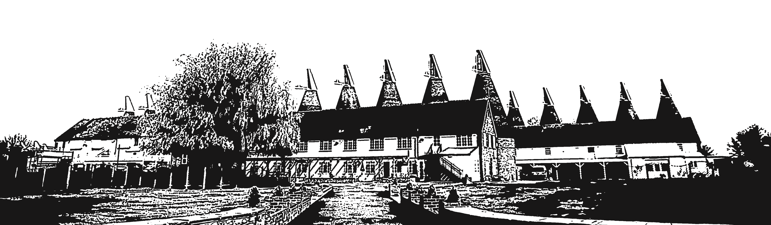
*Gluten Free and Dietry Requirements Availiable On Request*

ADDITIONAL EXTRAS

- Magician from £300
- Centre pieces from £15 each
- Photobooth from £650
- Welcome Drink from £2 per person

*Additional security will be required for numbers over 100 guests*

Prom Terms and Conditions

• Prom package includes Menu Options, DJ and Security only. Venue hire is to be purchased separately.
• All contracts are to be signed on behalf of the School. Contracts are to be sent back to The Hop Farm with a copy of your school ID as proof. The Signatory needs to be present at all times during the event, and should any problems arise this person will be deemed as the responsible contact at all times.
• There needs to be at least 1 teacher/parent per 20 students who will be present until all students have left site.
• Alcohol at your event has to be pre-organised with The Hop Farm prior to your event in writing. If it is deemed that due to the age of the students your event is a non-alcoholic event, no one including teachers/parents will be served or admitted on site.
• Security will be provided by The Hop Farm and Full Bag Checks will be done on entry to the Venue. The Hop Farm reserves the right to confiscate and not return any alcohol and substances found during the searches.
• The Hop Farm also reserves to right to ID and run a challenge 25 policy.
• If anyone is deemed to be under the influence of Drinks or Drugs by security they will not be allowed entry to the venue.
• The responsible person as stated above will be asked to supervise alongside security at the entry point until it is deemed that most students are in the venue.
• No persons under the age of 18 are permitted to exit the venue other than to leave The Hop Farm site entirely, no re-entry will be permitted under any circumstances.
• If the hirer terminates this agreement, then the Hirer shall pay to the Owner a Cancellation Charge of 100% within 3 months of the event date, 50% before 3 months of the Event date of the total Event Fees. Any deposits paid are non-refundable or able to be transferred to an alternative date.
• By signing the agreement you are agreeing to the Terms and Conditions and Cancellation Charges for your event.

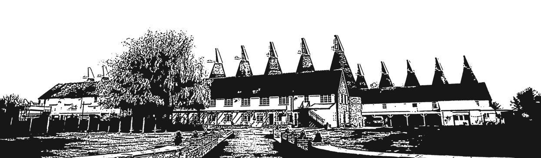
Contact:………………………………………………………….

Signed:………….…..……………………………………………

Date:……………………………………………………………..

