Venue Hire

Venue Capacity
Function Room | The Dray | Dray Marquee | Whites | Shires | Roundel
U-Shape | 70 | 70 | 30 | 20 | 12
Boardroom | 80 | 90 | 40 | 30 | 12
Theatre | 400 | 340 | 150 | 30 | 12
Classroom | 150 | 120 | 120 | 20 | 12
Cabaret | 200 | 220 | 120 | n/a | 10
Dinner Dance | 150 | 200 | 90 | 40 | n/a
Reception | 300 | 450 | 180 | 170 | n/a

Room Rates
Monday-Friday Half Day = 8am - 12pm OR 1pm - 5pm
Monday- Friday Full Day = 8am - 5pm

Shires
Half Day £325 + VAT
Full Day £450 + VAT
Whites
Half Day £325 + VAT
Full Day £450 + VAT
Roundels
Half day £150 + VAT
Full Day £200 + VAT
Dray
Half Day £750 + VAT
Full Day £1000 + VAT

Additional £50.00 per hour room charge for every hour before 8am and after 5pm

Corporate Evening and Weekend Hire
Includes use of the Bar, and Bar Staff

Exclusive Weekend Hire 9am-12am
From £1500+VAT
Exclusive Evening Hire 6pm-12am
From £750+VAT

Refreshment Options

Unlimited Tea & Coffee
Half Day £3.00+ VAT pp
Full Day £3.50+VAT pp
Bacon, Sausage or Egg Baps
£2.90+VAT pp
Breakfast Pastries
£2.00 +VAT pp
Jug of Apple/Orange Juice
£4.50+VAT each

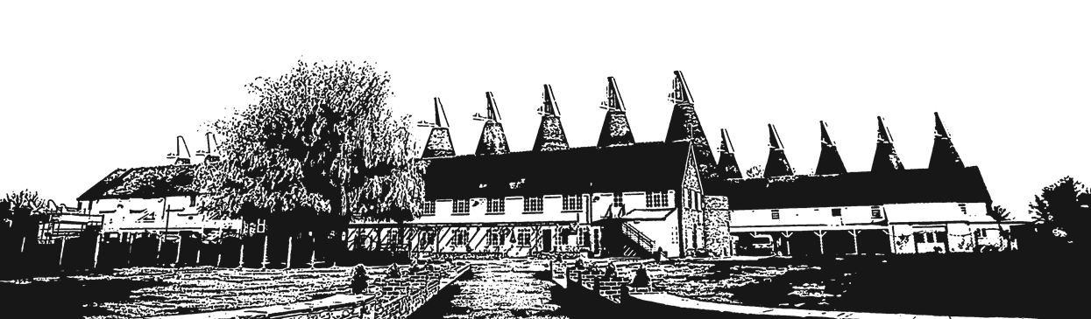
Food Options
Price includes all table linen and napkins required

Sandwich/Baguettes & Tortilla Crisps
£4.50+VAT pp

Soup Luncheon
(Min 10 Guests)
£7.00+VAT pp

Jacket Potatoes & Salad
(Min 15 Guests)
£8.00+VAT pp

BBQ Buffet
(Min 30 Guests)
£16.60+VAT pp

Hog Roast
(Min 80 Guests)
Bap Only £8.50+VAT pp
Buffet £16.60+VAT pp

Finger Buffet
Chef’s choice £10.25+VAT pp
Choose 6 items £12.25+VAT pp

Hot Fork Buffet
£15 +VAT pp

3 Course Sit Down Dinner
(Min 30 Guests)
From £29.95+VAT pp
*Add a Dessert Table for just £3+VAT per person*

Day Delegate Rate
(Minimum of 15 People)

Full Day 8am-5pm
£26+VAT pp

- Hire Of One Room
- Biscuits on Arrival
- Pads and Pens
- Flip Chart
- Water and Cordial
- Projector and Screen
- Unlimited Tea and Coffee throughout the day
- Working Sandwich Lunch

Half Day 8am-12pm/1pm-5pm
£17+VAT pp

- Hire Of One Room
- Pastries on Arrival
- Pads and Pens
- Flip Chart
- Water and Cordial
- Projector and Screen
- Unlimited Tea and Coffee throughout session

*Complementary WI-FI is available in each of our meeting rooms excluding the Dray Marquee*

*Pricing for further AV equipment, Staging and Flipcharts are available on request*

Finger Buffet Upgrade Option
Upgrade your Sandwich Lunch and add 5 of the options below for just £4+VAT per person

- Potato Wedges with Various Dips (G) (V)
- Hummus and Crudités (G) (V)
- Marinated Chicken Kebabs (G)
- Vegetable Spring Rolls (V)
- Green and Black Olives
- Southern Fried Chicken Strips
- Falafel Bites (V)
- A Selection of Bruschetta;
Chef’s Pâté with Chutney – (G) also available
- Honey & Mustard Glazed Cocktail Sausages
- Sausage Rolls
- Pesto and Cheese Twirls
- Homemade Coleslaw
- Vegetable Quiche

Buffet Upgrade Options
Upgrade your Sandwich Lunch to a Hot Fork Buffet, please choose up to three options for just £6+VAT per person

Vegetable Tagine and Cous Cous
Sweet and Sour Chicken Served With Noodles
Beef Chilli Served with Jacket Potatoes
Lasagne (Mince or Vegetable), Garlic Bread, and a Tossed Salad
Butternut Squash, Aubergine, Pomegranate Seeds and a Feta Moussaka
Tuna Pasta Bake Served with a Tossed Salad
Chicken or Vegetable Curry Served With Rice and Naan

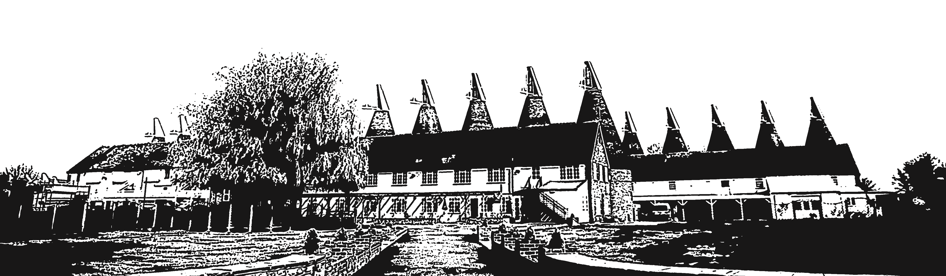
,

Add Fruit Platters or Dessert Items For Just £3+VAT per person

*Additional Dietry Requirements Availiable On Request*

Corporate Menus

Sandwich / Baguettes & Tortilla Crisps
£5.50+VAT per person

A Selection of sandwiches and rolls served on a platter with tortilla crisps. Meat and vegetarian filling are available.
Paninis are also available for parties with less than 20 guests.

Soup Luncheon
£7.00+VAT per person
Minimum 10 Guests

- Choose one of the following Soups;
  - Country Vegetable Soup
  - French Onion Soup
  - Tomato & Basil
- Bread Basket & Spread
- Crudité & Hummus
- Sweet Potato Falafel Bites
- Ginger & Lemongrass Chicken Skewers

Jacket Potatoes & Salad
£8.00+VAT per person
Minimum 10 Guests

- Jacket Potatoes
- Mixed Leaf Salad
- Tuna Mayo
- Grated Cheese
- Marinated Chicken & Sweetcorn
- Quiche
- Wholemeal Pitta Bread & Hummus
- Tomato & Cheese Bruschetta

BBQ Buffet
£16.60+VAT per person
Minimum 30 Guests

- Home Style 100% Beef Burger
- Locally Sourced Sausage
- Marinated Chicken Kebab
- Soft Flour Bap

- Jacket Potatoes OR Potato Wedges
- Mixed Seasonal Leaves with House Vinaigrette
- Tomato Salad with Red Onions and Basil
- Chunky Homemade Coleslaw
- Spicy Rice Salad
- Selection of Vegan & Vegetarian Items

Hog Roast
Bap only - £8.50+VAT per person
Buffet - £16.60+VAT per person
Minimum 80 Guests, only available April-October.

- Slow Roasted Pig
- Crispy Crackling
- Soft Flour Bap
- Stuffing
- Apple Sauce
- Jacket Potatoes OR Potato Wedges
- Mixed Seasonal Leaves with House Vinaigrette
- Tomato Salad with Red Onions and Basil
- Chunky Homemade Coleslaw
- Selection of Vegan & Vegetarian Items

Finger Buffet Menu
Chefs Choice £10.25+VAT per person OR Choose 6 items £12.25+VAT per person
Chefs Choices options will include a selection of the below or please choose 6 items,

- Potato Wedges and Dips
- Hummus and Crudités
- Cajun Coated Fine Beans
- Onion Rings
- Mini Onion Bhaji
- Dim Sum Selection
- Green Olives
- Vegetable Spring Rolls
- Selection of Sandwiches and Rolls
- A Selection of Bruschetta
- Honey & Mustard Cocktail Sausages
- Sausage Rolls
- Homemade Coleslaw
- Green Leaf Salad
- Garlic Bread
- Sweet Potato Falafel Bites
- Roasted Tomato Couscous
- Chicken Bites
- Ginger & Lemongrass Chicken Skewers
- Vegetable Quiche

*Fresh Fruit and Cakes available on request*

Hot Fork Buffet
£15+VAT per person
Choose from three of our Hot Fork Buffet options below

Vegetable Tagine and Cous Cous
Sweet and Sour Chicken Served With Noodles
Beef Chilli Served with Jacket Potatoes
Lasagne (Mince or Vegetable), Garlic Bread, and a Tossed Salad
Butternut Squash, Aubergine, Pomegranate Seeds and a Feta Moussaka
Tuna Pasta Bake Served with a Tossed Salad
Chicken or Vegetable Curry Served With Rice and Naan

3 Course Sit Down Dinner
£29.95+VAT per person
Minimum 30 Guests. Please choose two items from each course including vegetarian dishes if required.

STARTER
Tomato and Basil Soup with Croutons
Seasonal Melon with a Berry Coulis
Chef’s Pate Served with an Onion Relish and Melba toast
Marinated Chicken Skewers on a Bed of Rocket

MAIN
Chicken with a Tarragon and White Wine Cream Sauce
Sweet Potato and Mushroom Stout Tart
Beef Lasagne with Garlic Bread and Side Salad
Luxury Fish Pie with a Mashed Potato Topping

All main courses are served with a selection of seasonal vegetables, and choice of Dauphinoise, Potato Wedges or Crushed New Potatoes

DESSERT
Chocolate and Orange Torte
Lemon and Raspberry Posset
Fruity Berry Amore Cake
Trio of cheesecakes

Vegan/Gluten and dietary requirements available
*Please inform us of any dietary requirements or allergies prior to your function*

ALTERNATIVELY WE CAN CREATE A BESPOKE MENU ESPECIALLY FOR YOU. PRICE ON REQUEST.

Team Building Days
(Prices based on events taking place Monday-Friday, weekends may require an additional fee)

Time Quest Package
10-50 people - £40 + vat Per Person

- Meeting Space 9am-1pm
- Pastries on Arrival
- Unlimited Tea and Coffee
- Working Sandwich Lunch
- Flipchart
- Projector and Screen
- 1 Hour Long Afternoon Escape Room Game

Challenge Day
50-200 people - £65 + vat Per Person

- Room Hire 9am-5pm
- Pastries on Arrival
- Unlimited Tea and Coffee
- BBQ Style Lunch
- Flipchart
- Projector and Screen
- Last One Standing
- Obstacle Course
- Bungee Run
- Sumo Wrestling
- Tug of War
- Bottle of Water

Build Your Own Day
Prices are based on your own requirements, other options available please ask a member of our team.

Food & Drink

- Breakfast Baps
- Pastries
- Breakfast Buffet
- Unlimited Tea and Coffee
- Orange/Apple Juice
- Finger Buffet Lunch
- Hot Fork Buffet Lunch
- BBQ Buffet
- Hog Roast Buffet
- Bottled Water
- Use of Bar
- Chocolate Fountain
- Candy Floss Machine
- Popcorn Machine
- Sweetie Cart

Inflatables

- Last One Standing
- Bouncy Castles
- Obstacle Course
- Velcro Wall
- Mega Drop Slide
- Laser Tag Arena
- Bungee Run
- Gladiator Arena
- Sumo Wrestling
- Rodeo Bull
- Hungry Hippos
- Human Football Table
- Human Demolition Ball
- Wrecking Ball
- PLUS MANY MORE!

Field Games

- Rounder’s
- Croquet
- Tug of War
- Mini Golf
- Team Hoppers
- Footy Speed Cage
- Welly Wanging
- Giant Dominoes
- Garden Quoits
- Giant Connect 4
- Football Set
- Giant Jenga
- Carnival Games
- Bubble Football
- PLUS MANY MORE!

Entertainment

- Rat Pack Singer
- Live Rock Band
- DJ & Disco
- Stilt Walker
- Fire Breather
- Children’s Party Games
- Face Painter
- Presenters & Hosts
- Caricaturists
- Photo Booths
- Character Appearances
- Close Up Magic

Party Package
Suitable for Birthdays, engagements, anniversaries and celebrations

Party Package - £3000 Inc vat
Based on 100 Guests this package includes;

- Shires Evening Room Hire 7pm-12am
- Use of The Patio and Garden
- Afternoon Set-Up Time
- Cake Table
- Silver Cake Stand and Knife
- DJ and Disco
- Full Bar and Bar Staff
- Car Park At Close Proximity Of The Venue
- Hot and Cold Finger Buffet
- Present Table

*Additional guests are priced at £13 per person*
Upgrade to BBQ: Additional charge £8.50 pp

Additional Extras
For an additional fee we can provide any of the following;

- Late Licence until 1am
- Welcome Drinks
- Toasting Drinks
- Buffet Upgrade to a BBQ/Hog Roast
- Magician
- Photobooth
- Casino Tables
- Venue Decorating
- Sweet Table
- Inflatable Hire
- Karaoke
- Fireworks
- Soft Play Room (Under 5’s)
- Chocolate Fountain

*Terms and conditions apply, selected dates available.*
A non-refundable deposit of £1000 is required to secure your date and discounted price.

TERMS AND CONDITIONS (V113)

1. In this document, the following expressions have the following meanings: the Company means Kent Entertainment Ltd. The Organiser means the person or company who accepts a written quotation from the Company for contracted services. The Function means the programme of services to be offered within the Contract. The Contract is a legally binding agreement between the Company and the Organiser.

2. Once you have chosen your preferred venue hire options, considered our proposals and are happy that The Hop Farm is your choice of venue, please sign these terms and conditions, ﬁll out the booking form and return either by scanning and emailing to functions@thehopfarm.co.uk or by post to The Functions Team, Hop Farm, Maidstone Rd, Paddock Wood, Kent TN12 6PY and include your deposit of 50% of the total contracted fees or your full room hire fee – whichever is of the greater value.

3. All deposits/pre-event payments are non-refundable or transferable to alternative dates. Post-dated cheques are not acceptable and the Hirer is responsible for any bounced cheque fees.

4. If the Organiser terminates this agreement then the Organiser shall pay The Hop Farm a cancellation charge of 100% of the total contracted fees if cancelled within 3 months of the event date or 50% if cancelled before 3 months of the event date. All deposits/pre-event payments are non-refundable or transferable even if greater than the 50% balance. All cancellations must be made in writing and signed by the Organiser.

5. Your ﬁnal invoice will be based on the minimum numbers advised on your booking form. Any extra charges booked pre-event must be paid in full before your event date. Additional bar tabs must be settled before departure – card authorisation may be requested in advance.

6. Final function details with the full outstanding balance due must be conﬁrmed 14 days before your chosen date – failure to do this may result in your event being cancelled and ﬁnal balance still due. The Hop Farm reserve the right to change/amend menus/prices up to 3 months before the event date due to ﬂuctuating wholesale prices outside of our control.

7. The Company shall use all reasonable endeavours to supply the best possible Function using its resources and facilities to best possible effect within any agreed time and/or cost quotations provided to the Organiser.

8. The Company reserves the right to refuse participation on any Function programme if a representative of the Company believes an Organisers participant is under the inﬂuence of alcohol or drugs, and that their participation could be harmful to themselves or others on the Function programme. No alcohol is to be brought into the licensed venue without prior agreement. The Hop Farm will charge corkage post event if guests are found to have brought in their own alcohol. The Hop Farm reserve the right to ID check at all times under the Challenge 25 policy and decline service of alcohol if the correct ID is not produced. The Hop Farm reserve the right to bag searches and evictions at all times if deemed necessary.

9. The Company reserves the right to impose additional charges resulting in the event of:
a. Changes and additions ordered by the Organiser in relation to the
Function after the acceptance of the Company quotation, proposal and function sheet.
b. Damages caused by the Organiser or member of the Organisers party during the course of the Function, to include physical damage to property and contents and superﬁcial damages which may require commercial cleaning.

10. The booking is conﬁrmed once the signed Function Booking Form and Terms and Conditions have been sent and received by the Company. Once a booking has been conﬁrmed by any format then all cancellations, whether prior to deposit payment or at any stage prior to the event, must be made in writing.

11. Initial costings are based on the minimum number of participants set by the Company at the time of booking. Any variation to participant numbers (either higher or lower) could affect the Contract price. Final numbers will be taken for the Function 14 days prior to the scheduled date of the event.

12. The Company operates a comprehensive health and safety policy encompassing current legislation. It is the responsibility of the Organiser to ensure that participants meet the health and safety requirements of all current and applicable legislation. If the representative of the Company responsible for Health and Safety believes that there is an unacceptable level of risk to participants or the Company’s staff in commencing or continuing an activity then the activity will be cancelled or curtailed.

13. The Company shall not be liable for its failure to fulﬁl any of its
Contractual obligations if such is caused by reasons beyond its control including health and safety grounds.

14. All Function services are offered subject to availability.

15. Should the Organiser encounter a problem or complaint on the day, it is the responsibility of the Organiser to advise the Company on the day of the Function as soon as possible in order that the Company may have the opportunity to rectify or redress the matter. In general, the Company consider it unreasonable if the Organiser takes no action in this respect during the Event.

16. The Company is committed to ethical business. The Company strives continually to build long term business relationships with its clients.

17. It is important to appreciate that you are booking a function room within the Hop Farm visitor attraction/event venue which is open to the public at all times. The Hop Farm reserve the right to run events and other facilities within the park and surrounding areas during your function.

18. Please note the venue times you have booked: arrangements can be made for set up and drop offs prior to your function date, however this service is not guaranteed. Please talk to your account manager for additional costs to guarantee this service

